Notes Best Practices
- Logos
  - If you change the logo or add a second, include an alternative text description.
    - For example, “Norco College”, for the NC logo.
  - Do not include the word logo, picture, image, etc. in the alt text description.
- Participants
  - Please list participants present
- Optional Sections
  - Delete sections not used by a committee.
  - Make sure to delete extra blank lines.
- Adding text
  - To add new Headings, text or bulleted list use the pre-set styles in the template:
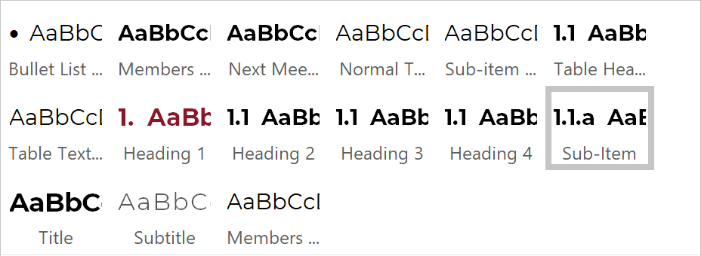
    - See below for details -Sample Template
  - Replace the text in parentheses with the information for the minutes.
    - It is recommended to type over the information instead of using copy and paste. You can use the insert key:
      - In Word, choose File > Options.
      - In the Word Options dialog box, choose Advanced.
Under Editing Options, select the Use Insert key to control overtype check box.
      - Press insert key to engage type-over feature, press insert again to dis-engage type-over feature and return to normal typing mode.

    - For example, replace “(Name of Committee/Task Force)” with “College Council”.
  - Avoid using additional bold, italics, or all caps within the document.
  - Underlining is reserved for hyperlinks.
  - Delete brackets and text within, example “[Normal Text Style]”.
- Lists
  - Use bulleted list if needed when adding details using Bullet list style.
  - Delete the entire line to remove an extra item from a list.
  - Adjust the list item levels using Tab.
- Follow-up Items Table cells
  - To add a Follow-up Items table, it is recommended to copy and paste an existing table. Remember to use Table Header Style to ensure proper numbering.
  - All Action, Discussion and Information items should have a follow-up table even if no follow-up items are identified.
  - Type “None” instead of leaving blank table cells.
  - Create new table rows for multiple items instead of using numbered or bulleted lists within a table cell.
  - Limit text in a table cell to one paragraph.
- Images
  - Always include an alt text description for images.

Sample Template identifying Pre-set Word Styles

(Name of Committee) [Title Style]

Minutes for (Date, Month Date, Year) [Title Style]
  - (00:00am-00:00pm) [Subtitle style]
  - (Location-do not use acronyms) [Subtitle Style]

Meeting Participants [Members Style]
Text [Normal Text Style]
- Objective of Meeting [Heading 1]
- Text [Bullet List Style]
- Items [Heading 1]
Text [Normal Text Style or Bullet List Style]
    - Conclusion (optional) [Heading 2]
Text [Normal Text Style or Bullet List Style]
- Corrections [Table Headings Style] | Task of | Due by
None [Table text style] | None | None

Future Agenda Topics (optional) [Heading 1]
- Text [Bullet List Style]

Adjournment [Heading 1]
- Time [Bullet List Style]
Next Meeting (optional) [Next Meeting Style]
Text [Normal Text Style or Bullet List Style]

