Agenda Best Practices
- Logos
  - If you change the logo or add a second, include an alternative text description.
    - For example, “Norco College”, for the NC logo.
  - Do not include the word logo, picture, image, etc. in the alt text description.
- Drafts.
  - Watermarks are not assessable please add “Draft of” before “Agenda for…”.
- Members
  - Identify co-chairs
- Optional Sections
  - Delete sections not used by a committee.
  - Make sure to delete extra blank lines.
- Adding text
  - To add new Headings or text use the pre-set styles in the template:
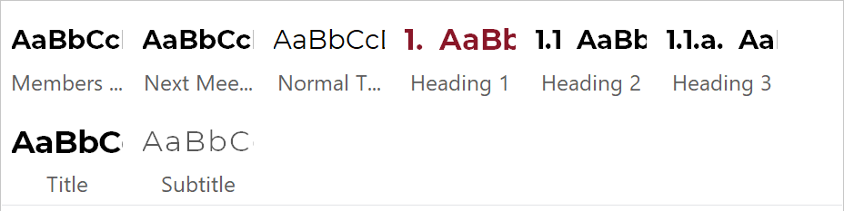
    - See below for details – Sample Template
  - Replace the text in parentheses with the information for the minutes.
    - It is recommended to type over the information instead of using copy and paste. You can use the insert key:
      - In Word, choose File > Options.
      - In the Word Options dialog box, choose Advanced.
Under Editing Options, select the Use Insert key to control overtype check box.
      - Press insert key to engage type-over feature, press insert again to dis-engage type-over feature and return to normal typing mode.

    - For example, replace “[Name of Committee/Task Force]” with “College Council”.
  - Avoid using additional bold, italics, or all caps within the document.
  - Underlining is reserved for hyperlinks.
  - Delete brackets and text within, example “[Normal Text Style]”.
- Mission Statement
  - Please include College Mission Statement on Agenda when space allows

Sample Template Pre-set Word Styles

(Name of Committee) [Title Style]

Agenda for (Date, Month Date, Year) [Title Style]
  - (Time) [Subtitle Style]
  - (Location-do not use acronyms) [Subtitle Style]
  - (Virtual Meeting details) [Subtitle Style]

Committee Members (total#) [Members Style]
(List members in any order used by the committee) [Normal Text Style]

Quorum: # [Members Style]

Subject to Brown Act: [Members Style]

Call to Order [Heading 1]

Reports/ Comments (optional) [Heading 2]

Action Items [Heading 1]

Approval of Agenda [Heading 1]

Approval of (date) Minutes [Heading 2]

(Action Item) [Heading 2]

Discussion Item [Heading 1]

(Discussion Item) [Heading 2]

(Discussion Sub-Item) [Heading 3]

(Discussion Sub-item) [Heading 3]

(Discussion Item) [Heading 2]

Information Items [Heading 1]

(Information Item) [Heading 2]

(Information Item) [Heading 2]

Good of the Order (optional) [Heading 1]

Future Agenda Topics (optional) [Heading 1]

Adjournment [Heading 1]
Next Meeting (optional) [Next Meeting]
Date [Normal Text Style]
Mission Statement [Next Meeting]
Norco College inspires a diverse student body by an inclusive innovative approach to learning through its pathways to transfer, professional, career and technical education, certificates, and degrees. We are proud to be a pivotal hub for scholarship, arts and culture, dynamic technologies, and partnerships. Norco College encourages self-empowerment and is dedicated to transforming the lives of our students, employees, and community.

