INSIDE THIS ISSUE:
Disbursements/BankMobile
FAFSA/CA Dream Act
Types of Financial Aid
New Updates
Student Academic Progress (SAP)
Scholarships
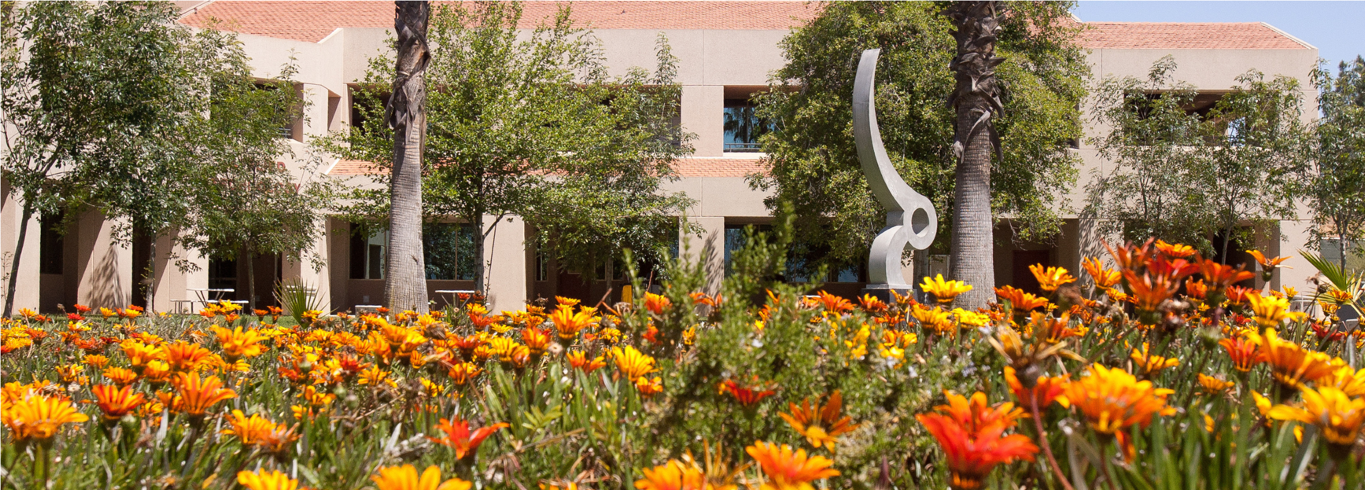
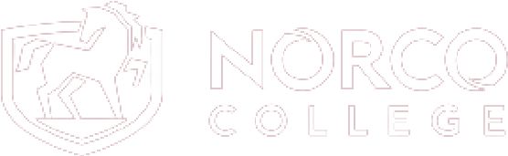
References/Resources
STUDENT FINANCIAL
SERVICES
NEWSLETTER
SPRING 2024 | VOLUME 1, ISSUE 2
SFS Staff/Contact us

OUR MISSION STATEMENT
The Student Financial Services Department of Norco College is committed to providing financial assistance to a diversified student population to help students in attaining their educational and professional goals. Student Financial Services student-centered employees provide professional knowledge and personalized service to ensure that lack of funds is not a barrier to students in pursuit of their educational objectives.

SPRING 2024
DISBURSEMENT DATES
Eligible students who met the 01/17/2024 task deadline.
- 1st Disbursement 02/15/24
- 2nd Disbursement 05/09/24
Eligible students who met the 02/01/2024 task deadline.
- 1st Disbursement 03/07/24
- 2nd Disbursement 05/09/24
Eligible students who met the 02/14/2024 task deadline.
- 1st Disbursement 03/28/24
- 2nd Disbursement 05/09/24
Eligible students who met the 03/06/2024 task deadline.
- 1st Disbursement 04/11/24
- 2nd Disbursement 05/09/24
Eligible students who met the 04/04/2024 task deadline.
- Only one Disbursement 05/09/24

Eligible students who met the 05/08/24 task deadline.
- Only one Disbursement 06/06/24
Eligible students who met the 06/07/24 task deadline.
- Only one Disbursement 07/19/24
BANKMOBILE DISBURSEMENT OPTIONS
Our method of disbursing financial aid funds to eligible Norco College students is via BankMobile disbursement services. Students can choose how they would prefer to receive their financial aid funds if eligible. First-time students will receive a welcome e-mail to their RCCD student e-mail account with a personal code. Follow the instructions in the welcome e-mail to select one of the following disbursement methods:
  - Direct Deposit to your own personal account (takes 1-3 business days to deposit)
  - BankMobile Vibe checking/savings account (deposits into account same day. Fees may apply)
  - Paper Check (takes about 5-7 business days to arrive from the date of disbursement)
Access your BankMobile account here at https://bankmobilevibe.com
Need assistance accessing your BankMobile account? Contact BankMobile at 1-877-327-9515
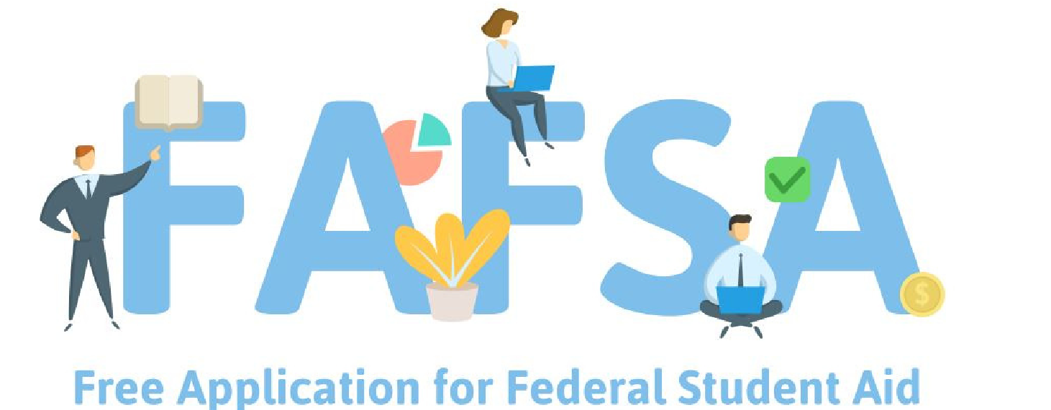
If you need financial assistance to pay for college, there is still time to apply! Submit your FAFSA and include Norco's school code 041761 on your application and ensure your social security number is on file with Admissions and Records.
WHICH APPLICATION SHOULD I COMPLETE?
Taking classes this Spring 2024 term? Complete your 2023-2024 FAFSA!
Taking classes this Summer/Fall 2024 & Winter/Spring 2025 term(s)? Complete your 2024-2025 FAFSA!
2024-2025 FAFSA opened on December 31, 2023
Complete your application before the April 2nd Cal Grant Deadline. APPLY NOW
APPLY NOW

TO COMPLETE YOUR APPLICATION, YOU WILL NEED:
Your/parent(s) Social Security Number
Your Driver’s License Number (if applicable)
Your 2021 Federal Income Tax Return (2021 taxes for the 23-24 FAFSA) Records of any Untaxed Income
Norco College’s school code 041761
WHAT FINANCIAL AID CAN I APPLY FOR WITH FAFSA?
Completing a FAFSA application allows students to apply for Federal and CA State financial aid that is available all year round.
See page 5 for a list of both Federal and State financial aid.

If you are not a U.S. citizen or an eligible noncitizen and need financial assistance to pay for college, there is still time to apply! Submit your CA DREAM Act and include the Norco College school code 04176100 on your application, and ensure you are AB540 eligible with Admissions and Records.
WHICH APPLICATION SHOULD I COMPLETE?
Taking classes this Spring 2024 term: Complete your 2023-2024 CA Dream Act!
Taking classes this Summer/Fall 2024 & Winter/Spring 2025 term(s)? Complete your 2024-2025 CA Dream Act!
Complete your application before the September 2nd Cal Grant Deadline.
APPLY NOW

TO COMPLETE YOUR APPLICATION, YOU WILL NEED:
To check your AB540 eligibility with Admissions and Records
Your 2020 Federal Income Tax Return (2021 taxes for the 23-24 FAFSA)
Records of any Untaxed Income
Norco College’s school code 04176100
WHAT FINANCIAL AID CAN I APPLY FOR WITH CA DREAM ACT?
Students who are not U.S. citizens or eligible non-citizens but are AB540 eligible should complete the California DREAM Act Application.
Completing a CA DREAM Act Application allows students to apply for CA State financial aid that is available all year round.
See page 5 for a list of State financial aid.

TYPES OF FIANANCIAL AID
Financial aid offered at Norco college comes from two places:
The Federal government and the state of California

FEDERAL AID
Pell Grant: Pell grants are available for students with financial need. Unlike most federal aid, this grant does not need to be paid back as long as you do not withdraw from classes, you successfully complete your classes and are not simultaneously receiving the Pell grant at another school. The amount of Pell grant displayed on your award letter is based on full-time enrollment. The amount of Pell grant paid will be prorated based on the number of units you are taking in each semester.
SEOG: The Federal Supplemental Education Opportunity Grant (FSEOG) is awarded to undergraduate students with the most financial need. Students with the highest need and are Pell grant eligible for the award year will have primary consideration for FSEOG awards. Non-resident students as well as Study Abroad students may also be eligible.
Federal Work Study: Federal Work-Study provides part-time jobs for students with financial need, allowing them to earn money to help pay education expenses through work. Students will be paid by the hour and receive a monthly paycheck.
Federal Loans: Subsidized and Unsubsidized loans are available to undergraduate students. An origination/guarantee fee will be subtracted by a federal agency before disbursement. The type of loan and actual loan amount you are eligible to receive each academic year varies depending on financial need, what year you are in school and whether you are a dependent or independent student.

STATE AID
CCPG (California college promise grant): The California College Promise Grant (CCPG) is a state fee waiver program that waives the per unit enrollment fee (currently $46.00 per unit). It is not a cash award. The CCPG also allows students to purchase parking at reduced rates for fall and spring semesters. The CCPG does not pay for Student Services, Transportation or Health fees, additional class fees (such as art, CPR, lab or lifeguard fees as listed in the schedule of classes), books, or other educational supplies or expenses.
Cal Grant: Cal Grants are state grants administered by the California Student Aid Commission (CSAC). These grants are awarded to California residents/eligible AB540 students to assist them in paying their educational expenses at any qualifying college or institution. Students will want to submit their FAFSA/CA Dream Act before the Cal Grant deadline of March 2nd of each year.
SSCG (Student Success Completion Grant): The Student Success Completion Grant (SSCG) encourages successful completion of a student’s educational goals by attending and completing full time units. This award is for students who are receiving a Cal Grant B or C award and attending 12 or more units per semester.
Chafee Grant: CSAC awards the Chafee Grant to current and former foster youth to use for career and technical training or college courses. The Chafee grant is awarded for up to $5,000 annually (or up to the unmet need) for students enrolled in 6 or more units during the Fall and Spring sessions.

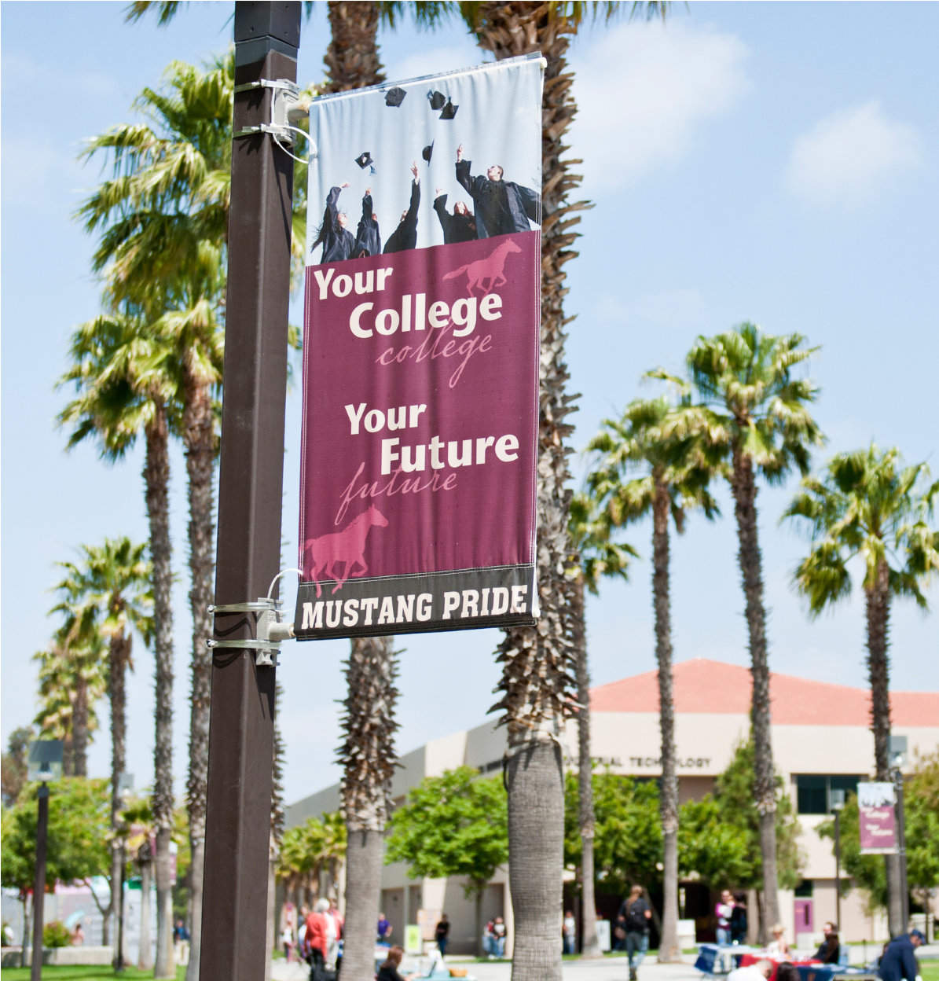
NEW UPDATES
THE CALIFORNIA DREAM
ACT SERVICE INCENTIVE
GRANT PROGRAM (DSIG)
The California Dream Act Service Incentive
Grant Program (DSIG) encourages California Dream Act Application (CADAA) students with a Cal Grant A or B award to perform community or volunteer service. The California Student Aid Commission (CSAC) will award up to $4,500 per academic year (up to $2,250 per semester or up to $1,500 per quarter) to 1,667 eligible students. Eligible students must be receiving a Cal Grant A or B award, maintaining Satisfactory Academic Progress, be a California resident, enrolled in at least half-time and demonstrate enough financial need.
OCELOT/LIVE CHAT
DSIG Info

Students can contact various departments at Norco College, including Student Financial Services, by using “Ask Monty the Mustang”! Visit out Website, NorcoCollege.edu, and ask Monty to speak with a “Live Agent” and you will be connected with a student services agent to answer your questions.

FINANCIAL AID TASKS
Submitting the FAFSA is the first step towards applying for financial aid. Some students who complete a FAFSA application will be required to submit verification documents to complete their financial aid file. Check your file status and complete pending tasks on the StudentForms portal and follow up on all requests from SFS to ensure your file is processed.
StudentForms

SUGGESTED SCHOLARSHIP SITES
www.careeronestop.org www.immigrantsrising.org www.fastweb.com www.scholarships.com www.studentscholarshipsearch.com

SCHOLARSHIPS
The 2024-2025 RCCD Foundation Scholarships application is open each year from October through January. The application for high school senior scholarships is open January through April. Complete just one application and be matched to multiple opportunities.
Students who applied for the 2023-2024 Foundation Scholarships can view their application status on the Scholarship site. Scholarship offers will be sent to students in May 2023.

EXTERNAL SCHOLARSHIPS
External scholarship opportunities are listed year-round on the district’s scholarship website. Visit the link below and navigate to the RCCD Scholarship Site to view the list of scholarships or search using key words.
Scholarships

STUDENT EMPLOYMENT
The Student Employment Program helps students earn money to pay for their educational expenses by working part-time (up to 20 hours per week) while learning transferable job skills. You can benefit from a flexible schedule that works around your classes, build resume experience and earn money while gaining work experience.
Apply today!
NC Connect/
JobSpeaker

ATTN: Student Employment Supervisors: Please submit student timesheets by email to: StudentEmploymentTimeSheet.NC@norcocollege.edu
Contact Us!
The Student Financial Services office is here to assist you with completing your FAFSA/CA Dream Act application. Please visit our office at least one hour before closing, to ensure enough time to complete your application.
For accurate business hours, please visit our website here.

PHONE:
(951) 372-7009
EMAIL:
STUDENTFINANCIALSERVICES@NORCOCOLLEGE.EDU
CAMPUS:
1ST FLOOR OF THE STUDENT SERVICES BUILDING

ALL APPLICATIONS FOR FINANCIAL ASSISTANCE PROGRAMS (I.E. STUDENT LOANS, WORK COMPENSATION, GRANTS, SCHOLARSHIPS, SPECIAL FUNDS, SUBSIDIES, PRIZES, ETC.) WILL BE CONSIDERED BY THE RIVERSIDE COMMUNITY COLLEGE DISTRICT WITHOUT REGARD TO RACE, COLOR, NATIONAL ORIGIN, SEX, DISABILITY, OR AGE. THE FOLLOWING PERSON HAS BEEN DESIGNATED TO HANDLE INQUIRIES REGARDING THE NON-DISCRIMINATION POLICIES OR PRACTICES:
DISTRICT COMPLIANCE OFFICER, 3801 MARKET STREET, RIVERSIDE, CA 92501, OR (951) 222-8039

